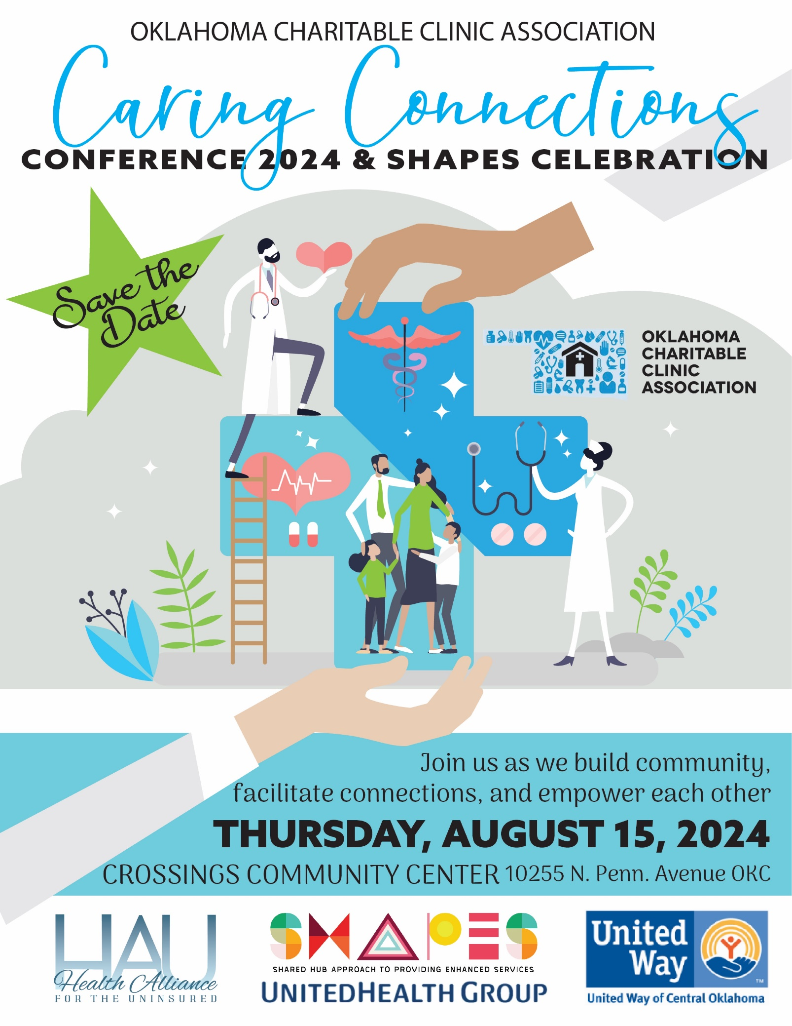
SPONSORSHIP PACKET
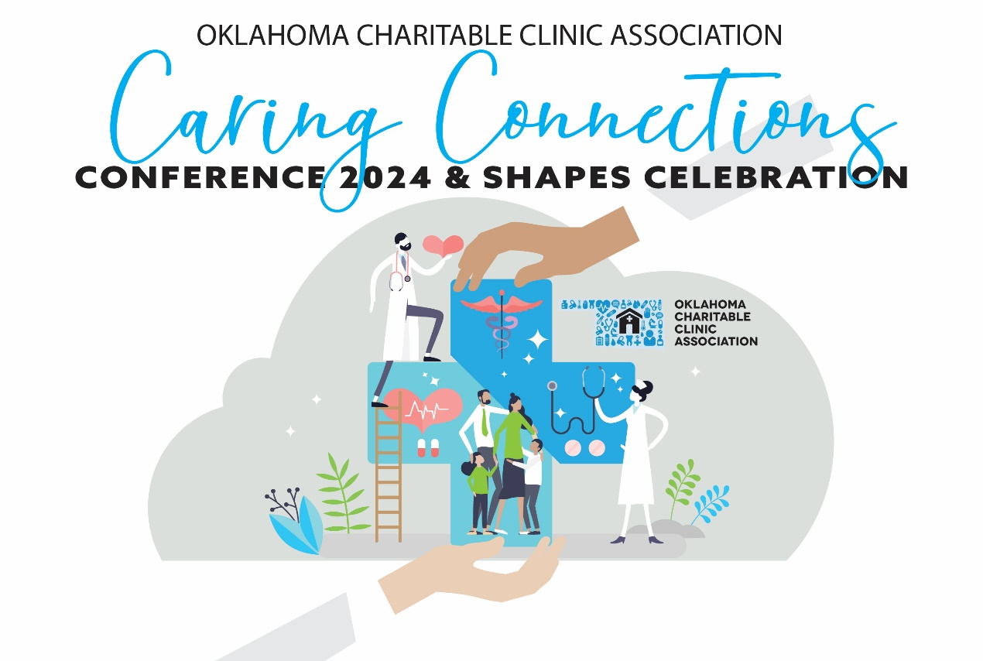
Date: Thursday, August 15, 2024  Place: Crossings Community Center  10255 N Pennsylvania Ave, The Village, OK 73120  Time: 9 a.m. – 4 p.m. CDT  The Oklahoma Charitable Clinic Association was organized in 2011 with the mission to support and strengthen the more than 60 charitable clinics in our state with collaborative efforts that improve the health of vulnerable Oklahomans.  As a 501(c)3 nonprofit, one of the ways we meet this objective is through our statewide conference, which provides networking, educational and informational opportunities.  If you are a nonprofit, state agency, or business that can provide products, services or information to charitable clinics or their patients, please support this effort by sponsoring an exhibit booth during the conference.  Your conference sponsorship at any level will ensure we have the funds necessary to conduct an effective conference and to provide services year-round to our clinic members.  Thank you for your support! |  | 2024 CONFERENCE SPONSORSHIPS  Gold Sponsor $2,000  - Sponsorship of one general session (including a 3-minute speech by your representative)  - Four complimentary individual conference registrations (including lunch)  - Ad in program; Logo & name billing on select conference materials  - One exhibit table (including electricity, if requested)  Silver Sponsor $1,000  - Sponsorship of a breakout session (including 3-minute speech)  - Three complimentary individual conference registrations (including lunch)  - Ad in program; Logo & name billing on select conference materials  - One exhibit table (including electricity, if requested)  Bronze Sponsor $500  - Two complimentary individual conference registrations (including lunch)  - Ad in program; Name billing on select conference materials  - One exhibit table (including electricity, if requested)  TO PURCHASE SPONSORSHIPS OR EXHIBIT TABLES:  Please fill out the sponsorship registration form on page two of this document. You have the option to pay by credit card or mail a check.  FOR MORE INFORMATION, PLEASE CONTACT:  Contact: Amber Hasty, Health Alliance for the Uninsured  Email: amber.hasty@hauonline.org

2024 Oklahoma Charitable Clinic Association Conference
Thursday, August 15, 2024

EXHIBITOR/SPONSOR APPLICATION
Company Name: _________________________________________________________________________
Contact Name: ___________________________________________________________________________
Mailing Address: _________________________________________________________________________
City/State/Zip: ___________________________________________________________________________
Phone: ___________________________________________ Fax: __________________________________
Email: ________________________________________________________________________________
PLEASE SELECT YOUR LEVEL OF SPONSORSHIP:
____ Gold - $2,000
____ Silver- $1,000
____ Bronze- $500
PAYMENT INFORMATION:
Total Payment: $____________
_______ Check Enclosed: Payable to: Health Alliance for the Uninsured
_______ Charge to Credit Card below or online at www.hauonline.org/donate
Name of Card Holder: __________________________________________________________________
Credit Card Number: ____________________________________________ Exp. Date: _____________
Type of Credit Card: ______ VISA ______ AMEX ______ MASTERCARD Security Code: _________

PLEASE RETURN THIS FORM TO:
Health Alliance for the Uninsured, 3000 United Founders Blvd Suite 219 Oklahoma City, OK 73112
Fax: 405-286-3349
Email: amber.hasty@hauonline.org

